1. Provide a screenshot of your Docker desktop to show the MongoDB and NiFi Docker *containers* running.

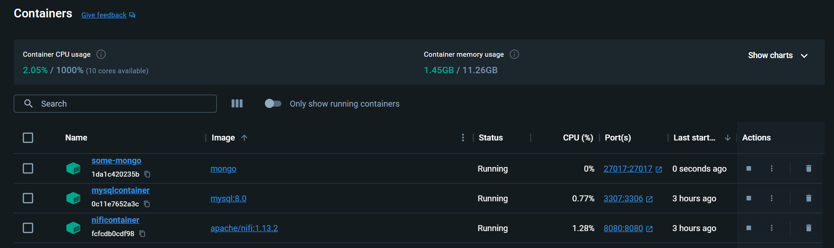

1. Provide a screenshot to show that the output *directory* exists in the NiFi *container*.



1. Provide a screenshot to show that you successfully populated the MongoDB database.

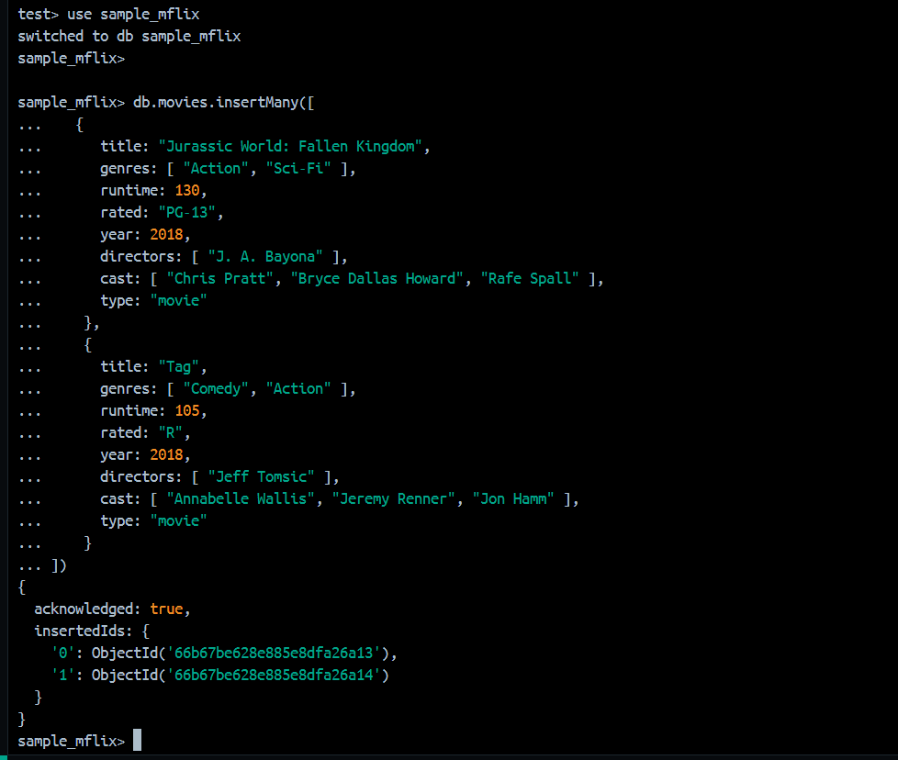

1. Provide a screenshot to show that you successfully created the new Activity17.3 process group.

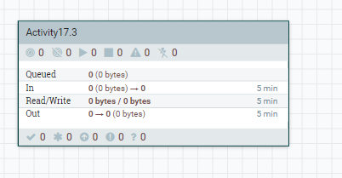

1. Provide a screenshot to show that you successfully added the GetMongo process group.

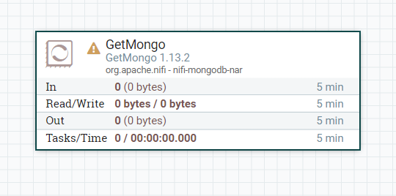

1. Provide a screenshot to show that you successfully configured the GetMongo *processor* to connect to the MongoDB database.

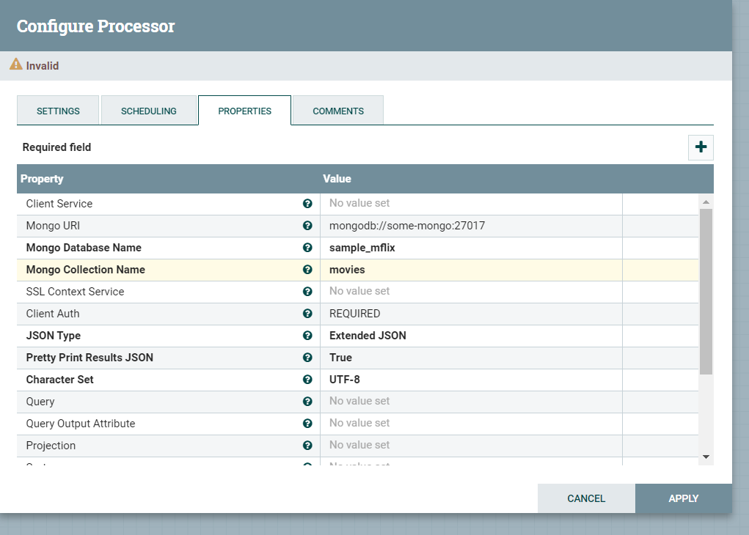

1. Provide a screenshot to show that you successfully added the PutFile *processor*.

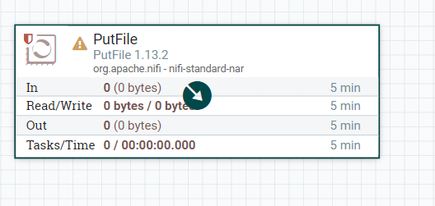

1. Provide two screenshots. The first screenshot should show that you set the values in the SETTINGS tab correctly. The second screenshot should show that you updated the scheduling time in the PROPERTIES tab correctly.

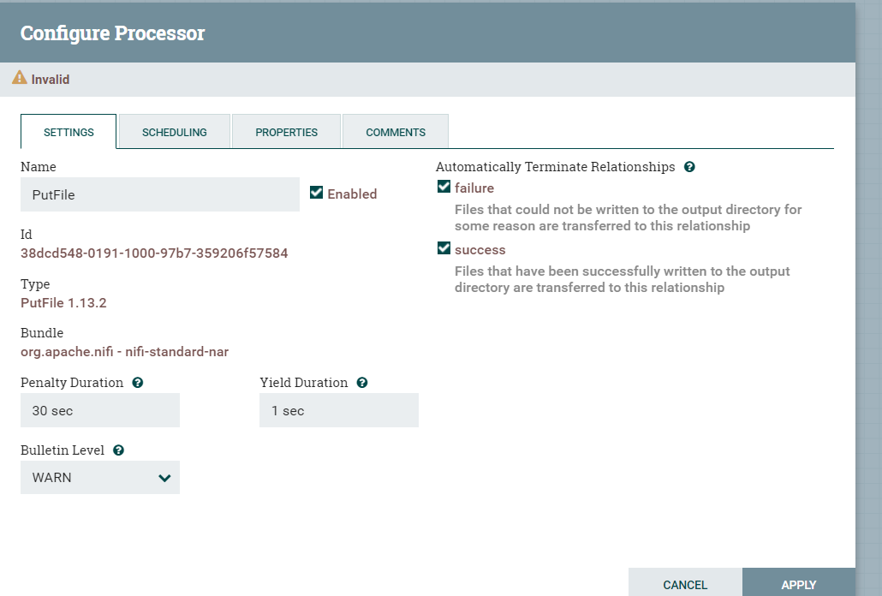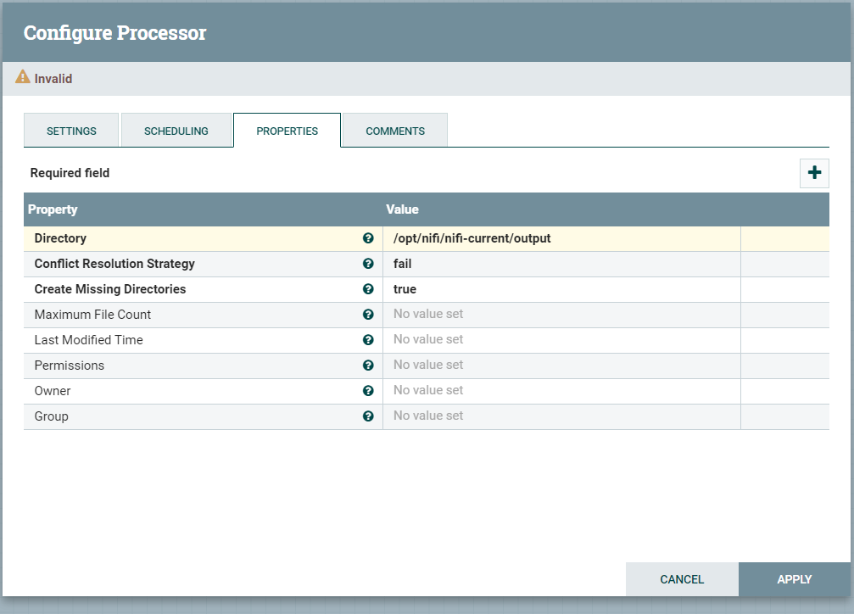

1. Provide a screenshot to show that you successfully created and configured the *connector* between the GetMongo and PutFile *processors*.

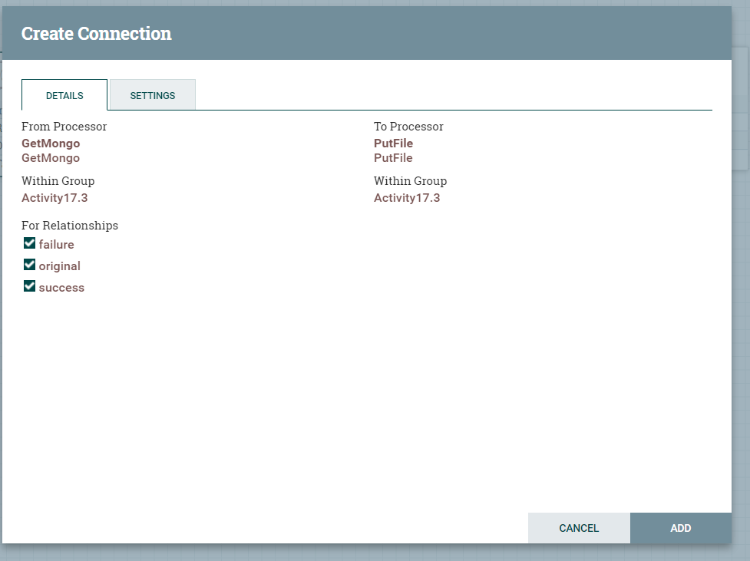

1. Provide a screenshot of the NiFi canvas to show the GetMongo and PutFile *processors* running.

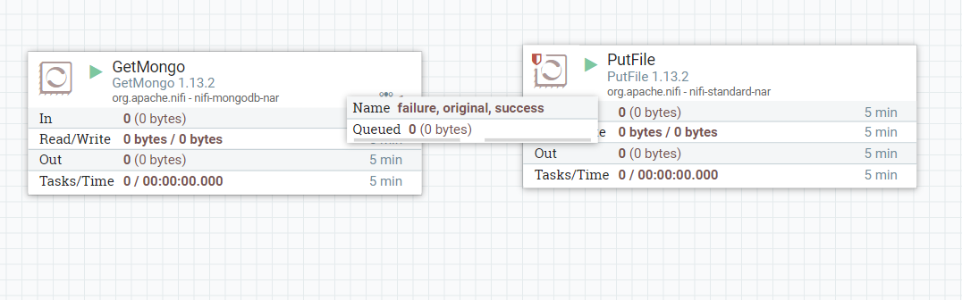

1. Provide a screenshot to show that the /opt/nifi/nifi-current/output *directory* has files being populated.

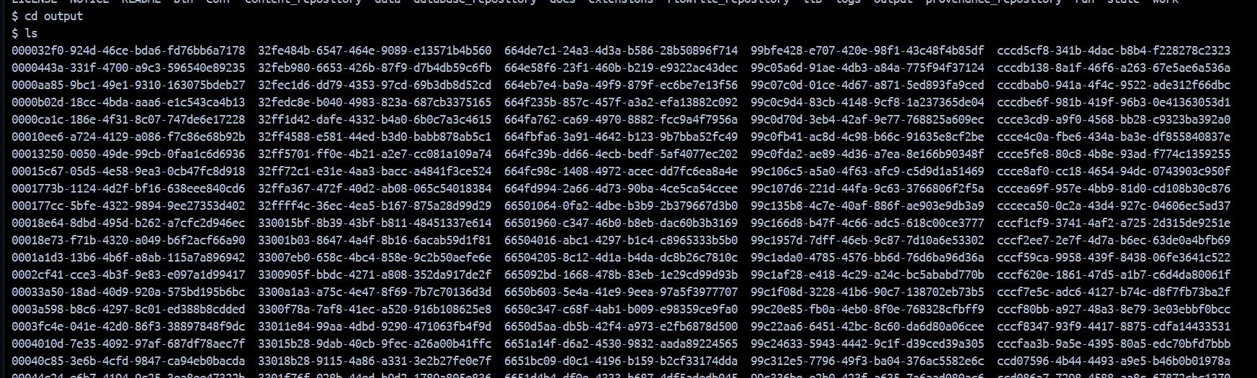

1. Provide a screenshot to show that you successfully issued the cat command to display the contents of one file.

